EXP NO 29 Priority-Based Interrupt Handling PROGRAM C++
#include <systemc.h> using namespace std;

SC_MODULE(PriorityInterrupt)
{
void process()
{
int interrupt[5] = {1, 2, 3, 4, 5};
int priority[5] = {3, 1, 5, 2, 4}; int temp;

// Sort according to priority for (int i = 0; i < 5; i++)
{
for (int j = i + 1; j < 5; j++)
{
if (priority[i] > priority[j])
{
temp = priority[i]; priority[i] = priority[j]; priority[j] = temp;

temp = interrupt[i]; interrupt[i] = interrupt[j]; interrupt[j] = temp;
}
}

}

cout << "Priority-Based Interrupt Handling:" << endl;

for (int i = 0; i < 5; i++)
{
cout << "Interrupt " << interrupt[i]
<< " - Priority " << priority[i] << endl;
}
}

SC_CTOR(PriorityInterrupt)
{
SC_THREAD(process);
}
};

int sc_main(int argc, char* argv[])
{
PriorityInterrupt obj("PriorityInterrupt");

sc_start();

return 0;
}

OUTPUT

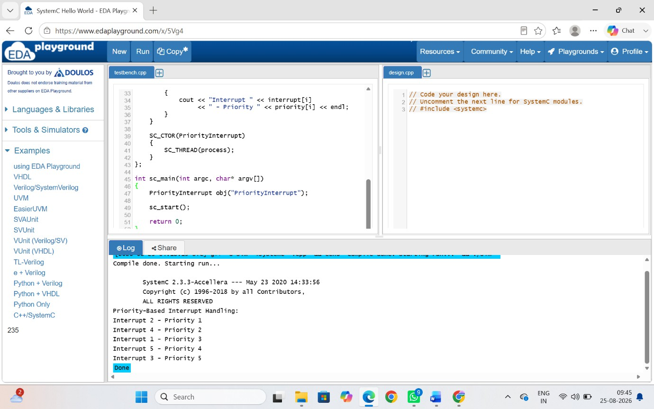

PROGRAM C
#include <stdio.h>

int main()
{
int interrupt[5] = {1, 2, 3, 4, 5};
int priority[5] = {3, 1, 5, 2, 4}; int i, j, temp;

for (i = 0; i < 5; i++)
{
for (j = i + 1; j < 5; j++)
{
if (priority[i] > priority[j])

{
temp = priority[i]; priority[i] = priority[j]; priority[j] = temp;

temp = interrupt[i]; interrupt[i] = interrupt[j]; interrupt[j] = temp;
}
}
}

printf("Priority-Based Interrupt Handling:\n");

for (i = 0; i < 5; i++)
{
printf("Interrupt %d - Priority %d\n", interrupt[i], priority[i]);
}

return 0;
}

OUTPUT

RESULT
Both C and C++ programs successfully implement priority-based interrupt handling and produce the same interrupt execution order, with C using printf() and C++ using cout for output.

